Real-Time Asteroid Detection & Analytics Pipeline (Check Point 2)

GitHub URL: https://github.com/Vishnuesilv/asteroid-realtime-pipeline

1. Overview of the Streaming Data Source
The objective of this project is to build a real-time big-data streaming pipeline capable of ingesting, processing, and storing asteroid data from the NASA Near-Earth Object (NEO) API.
The pipeline demonstrates:
- Real-time data ingestion
- Distributed message streaming (Kafka)
- Large-scale data processing (Spark Structured Streaming)
- Distributed storage (HDFS)
- System integration across a multi-node cluster
The goal is to prove that the infrastructure is configured correctly and that the pipeline works end-to-end from Kafka → Spark → HDFS.

2. Data (NASA NEO API)
Source: NASA Near Earth Object Web Service (NeoWs)
Endpoint used: https://api.nasa.gov/neo/rest/v1/feed?api_key=DEMO_KEY
The dataset contains:
- Asteroid ID
- Name
- Estimated diameter
- Relative velocity
- Miss distance from Earth
- Hazardous flag
- Close-approach timestamp
A Python producer collects this data every few seconds and streams it into Kafka.

3. Infrastructure Configuration (Your VM Setup)
Cluster Map (Your VM IPs + Roles)
Show which VM is master, which is worker, and which service runs on each.
Component | Role | Host/IP:Port | Notes
HDFS NameNode | Master | 10.0.0.5:9870 | Master VM
HDFS DataNode | Worker | 10.0.0.4:9864 | Worker VM
Spark Master | Master | 10.0.0.5:7077, UI: 8080 | Running
Spark Worker | Worker | 10.0.0.4 | Running
Kafka Broker | Master | 10.0.0.5:9092 | Single broker
Topic: asteroid_raw | Kafka | master:9092 | Created

4. Working Pipeline (End-to-End Flow)
Here is your architecture pipeline explanation:
Producer Layer
A Python script calls the NASA-NEO API and sends JSON messages to Kafka topic:
asteroid_raw
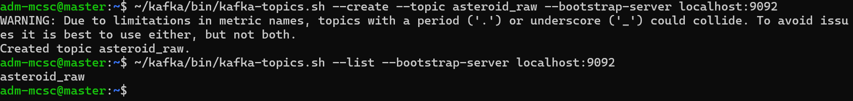
Kafka Messaging Layer
Kafka (running on master VM) stores incoming asteroid messages.
This acts as the buffer for real-time ingestion.
Spark Structured Streaming
Spark consumer job reads the Kafka topic continuously:
spark-submit --master spark://10.0.0.5:7077 spark_stream_processor.py
Spark:
- Parses the JSON
- Extracts important attributes
- Writes them into HDFS in Parquet format
Storage Layer (HDFS)
Output directory:
/asteroid_raw/
prove successful landing into distributed storage.
Architecture Schema
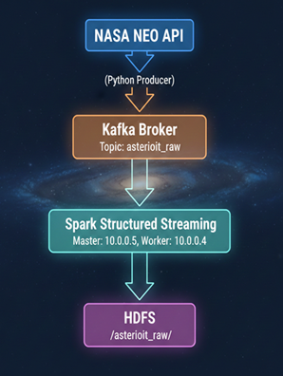

5. Screenshots
5.1. HDFS Directory Listing

5.2. Master jps
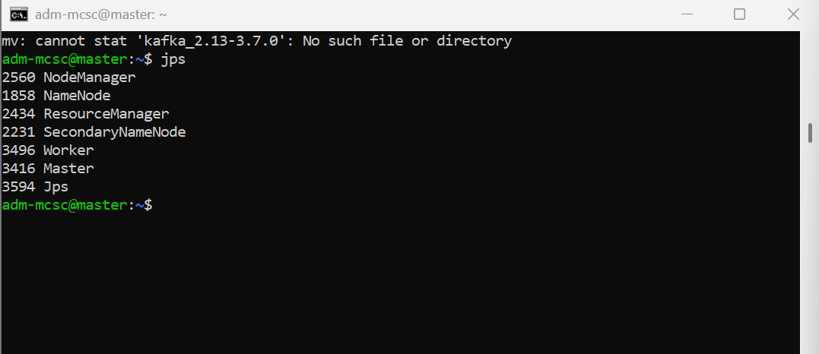

5.3. Worker jps
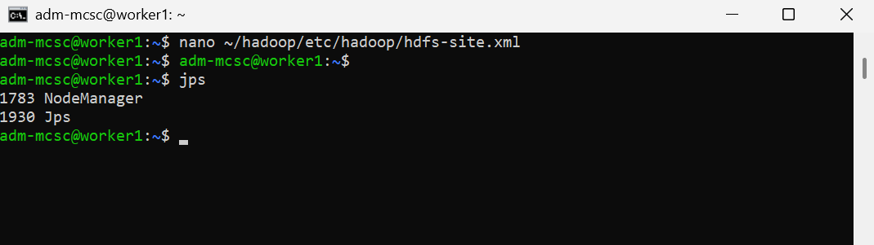

5.4. Kafka Topic Created
5.5. Producer Running (Sending Messages)
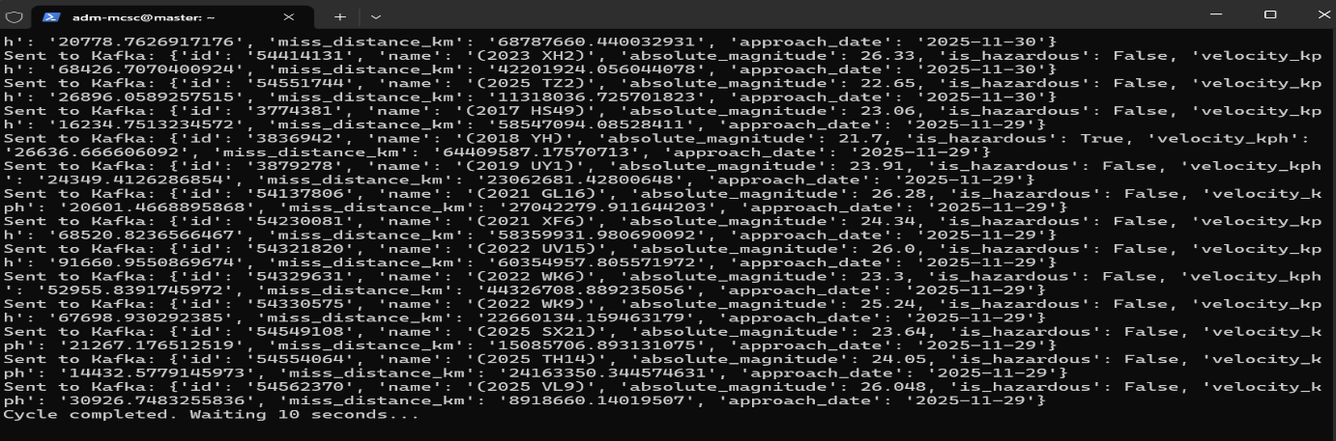

5.6. Spark Consumer Running
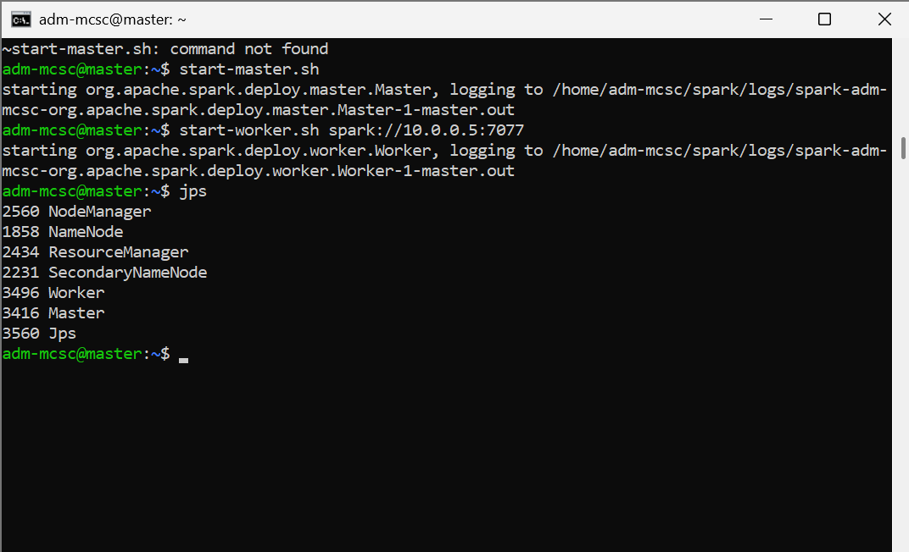

6. Member Roles (Solo Work)
Student | Role | Contribution
Vishnu Muralikrishnan | Full-stack Data Pipeline Developer | Installed and configured Hadoop, Spark, Kafka across 2 nodes. Created Kafka topic. Implemented real-time Python producer. Validated HDFS storage. Designed architecture. Wrote documentation and conducted demo.

